1. Extract the ZIP file to a folder on the computer's hard drive.
2. Run the file called Test_12_IPA Manager_V1.0.0.exe.
3. Contact SIIG support at https://www.siig.com/support/support-form. Send the Machine Number to SIIG Support.

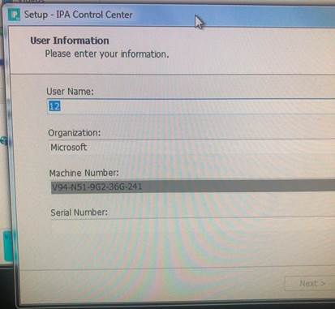

- Support will generate a serial number for your system.
- Enter the serial number.

