

***Quad-View HDMI 2.0 4K 60Hz KVM MultiView Processor***

***<P/N:*** ***CE-H26311-S1 >***

**Features**

* Not only to switch 4 HDMI video sources to one display via HDMI output, but also real time control 4 host device by one set of keyboard and mouse
* Supports mouse cursor to cross from one window to the other freely by moving the mouse without pressing front panel button in quad view mode
* Supports video screen layout included full screen mode and the very popular full quad view display mode
* Up to 5 unit of Multiview KVM processor can be cascaded and support up to 16 host devices to display on a single display device
* Supports 4K@60Hz full screen and quad view layout configuration
* Supports Input/Output resolution up to 4K@60Hz 4:4:4 color sampling
* Support upscaling up to 4K@60Hz 4:4:4 color sampling
* Support Deep Color and HDCP 1.4/2.2
* Fast switching between the input channels or the screen layout modes
* Receive Dolby Digital 5.1, DTS 5.1 and uncompressed 7.1 linear PCM audio including stereo analog audio input
* Support stereo audio output
* Support Keyboard/Mouse, front panel button, IR remote control, RS-232/Telnet and Web UI control
* Supports USB port firmware upgrade

**Package content**

* Quad-View HDMI 2.0 4K 60Hz KVM MultiView Processor
* Remote Control
* DC 12V/2A output power adapter
* Rack Mount Bracket (2)
* Rubber Pad (4)
* Screws bag
* Quick Start Guide

**Specifications**

|  |  |
| --- | --- |
| Product |  |
| Standard | HDMI 2.0, HDCP 2.2 |
| Connector Type | 4 x 19-Pin, HDMI, Input  4 x 4-pin, USB 2.0 Type-B, USB Host device  2 x 19-pin, HDMI, output  2 x 4-pin, USB 2.0 Type-A, Keyboard/Mouse  1 x 8-pin RJ-45, Ethernet, control  1 x 4-pin, USB 2.0 Type-A, for FW upgrade  1 x 9-pin RS-232 serial, control  1 x 3-pin terminal block, Audio output |
| Video resolution | 3840x2160@60Hz; 3840x2160@50Hz; 3840x2160@30Hz 1920x1080@60Hz; 1920x1200@60Hz  1600x1200@60Hz; 1280x720@60Hz  640 x 480@60Hz |
| Audio | Stereo |
| LAN port | RJ-45 connector for 10/100 BASE-T CAT-5 extension |
| Serial port | DB-9 RS-232 female connector |
| Operation Temperature | 0 - 45 degree C (32 to 112 degree F) |
| Control | Front Panel buttons  IR remote control  RS-232 / Telnet  Web UI |
| Storage Temperature | -20 to 60 degree (-4 to 140 degree F) |
| Relative Humidity | 20%~90% RH |
| Power supply | DC 12V/2A, locking barrel connector |
| Power consumption | 15W (Max) |
| ESD protection | Air gap discharge +-8KV, contact discharged +- 4KV |
| Dimension (W*H*D) | 440.4 x 45 x 230 mm (17.32” x 1.77” x 9.06”) |
| Net Weight | 2.80 kg |

**Product Layout**

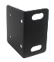

**1**

**2**

**3**

**4**

**5**

**Front Panel** 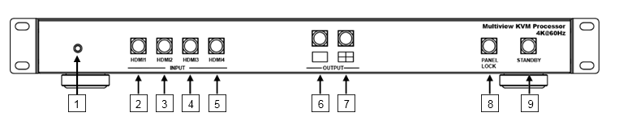

|  |  |  |  |  |  |
| --- | --- | --- | --- | --- | --- |
| **1** | **IR Sense** | **4** | **HDMI 3 Button** | **7** | **Quad View screen** |
| **2** | **HDMI 1 Button** | **5** | **HDMI 4 Button** | **8** | **Panel lock** |
| **3** | **HDMI 2 Button** | **6** | **Full Screen output** | **9** | **Stand by** |

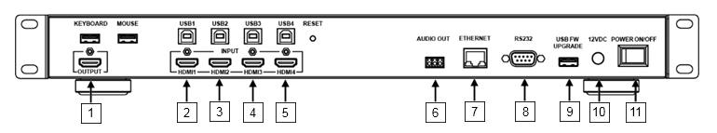

|  |  |  |  |  |  |  |  |
| --- | --- | --- | --- | --- | --- | --- | --- |
| **1** | **HDMI Output** | **4** | **HDMI 3 Input** | **7** | **Ethernet** | **10** | **12V DC** |
| **2** | **HDMI 1 Input** | **5** | **HDMI 4 Input** | **8** | **RS-232/Telnet** | **11** | **Power On/Off** |
| **3** | **HDMI 2 Input** | **6** | **Audio Output** | **9** | **USB FW** |  |  |

**Application**

1. Full screen
2. Quad view screen layout



1. Up to 5 unit for 16 host devices controlled by 1 set of keyboard and mouse



